Objective :

Use this notebook 3-fold:
* Play with parameters and visualize how (1 + x)^n grows compared to 1 + nx
* Compute how much money you will have on day n given the starting cash if you earn x% every day
* Determine when you will reach the specified wealth given the starting sum and the percentage you earn every day

%matplotlib inline

import matplotlib.pyplot as plt
import numpy as np

# You can play with the range of values for n and with the base 1.02, see what changes
sample = 200
x = np.arange(sample)
# This is used to plot the graph of 1.02^n, it is blue on the picture below
y = 1.02 ** x
plt.plot(x, y)
plt.xlabel('n')
plt.ylabel('Money($)')
# This is used to plot the graph of 1 + 0.02 * n, it is green on the picture below
z = 1 + 0.02 * x
plt.plot(x, z)
plt.show()

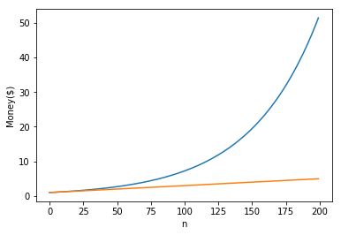

# Computes how much money you will have on day *day*, if you start with *starting_amount* of cash
# and earn *earn_percent* percents of what you already have every day.
def HowMuchMoney(starting_amount, earn_percent, day):
day_multiplier = 1 + (earn_percent / 100.0)
return starting_amount * (day_multiplier ** (day - 1))

def PrintExample(starting_amount, earn_percent, day):
print("If you start with $%d and earn %d%% each day, you will have more than $%.0f on day %d!" %
(starting_amount, earn_percent, HowMuchMoney(starting_amount, earn_percent, day), day))

# Prints what will happen by day 350 if you start with $1000 and earn 2% every day
# Feel free to play with the parameters
PrintExample(1000, 2, 350)

Output : If you start with $1000 and earn 2% each day, you will have more than $1003367 on day 350!
In [3]:

# Compute the number of the first day when your wealth will exceed *target_amount*,
# if you start with *starting_amount* of cash and earn *earn_percent* percents every day
def DayToReachTarget(starting_amount, earn_percent, target_amount):
day = 1
amount = starting_amount
day_multiplier = (1 + (earn_percent) / 100.0)
while amount < target_amount:
day += 1
amount = amount * day_multiplier
return day

def PrintFirstDay(starting_amount, earn_percent, target_amount):
print("If you start with $%d and earn %d%% each day, you will have more than $%d on day %d for the first time!" %
(starting_amount, earn_percent, target_amount, DayToReachTarget(starting_amount, earn_percent, target_amount)))

# Prints when you will get more than $1000000 for the first time, if you start with $1000
# and earn 2% every day.
PrintFirstDay(1000, 2, 1000000)

Output : If you start with $1000 and earn 2% each day, you will have more than $1000000 on day 350 for the first time!
In [ ]:

